**Alerts in Selenium:**

Alert is a pop up window that comes up on screen.

**Application areas:**

* Alert functions are used mainly in banking, e-commerce sites.
* Online application forms

There are many user actions that can result in an alert on screen. For e.g. user clicked on a button that displayed a message or may be when you entered a form, HTML page asked you for some extra information.

Alerts are different from regular windows. The main difference is that alerts are blocking in nature. They will not allow any action on the underlying webpage if they are present.

**Three types of alerts: Web-Based Popups**

1. Simple alert

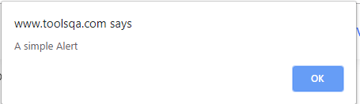

A simple alert just has an OK button on them. They are mainly used to display some information to the user. The very first alert on the test page is a simple alert.

1. Confirmation alert

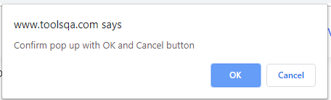

This type of alert comes with an option to accept or dismiss the alert. In order to accept the alert, you can use the Alert.accept()and to dismiss, use Alert.dismiss()

1. Prompt alert

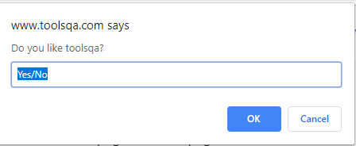

In prompt alerts, you get an option to add a text field to the alert box. This is specifically used when some input is required from the user. You can use the sendKeys() method to type some text in the Prompt alert box.

Selenium provides us with an interface called Alert. It is present in the org.openqa.selenium.Alert package. Alert interface gives us following methods to deal with the alert:

**How to Handle Alerts**

1. **accept()** To accept the alert

driver.switchTo().alert().accept();

1. **dismiss()** To dismiss the alert

driver.switchTo().alert().dismiss();

1. **getText()** To get the text of the alert

driver.switchTo().alert().getText();

1. **sendKeys()** To write some text to the alert

driver.switchTo().alert().sendKeys("Text");

driver.switchTo().alert() – to switch from main window to an alert

**public** **class** SwitchAlerts {

**public** **static** **void** main(String[] args) {

WebDriver driver = **new** ChromeDriver();

// Maximize window

driver.manage().window().maximize();

driver.get("https://demoqa.com/alerts");

driver.manage().timeouts().implicitlyWait(Duration.ofSeconds(10));

//to perform Scroll down on application using Selenium

/*JavascriptExecutor js = (JavascriptExecutor) driver;

js.executeScript("window.scrollBy(0,250)", "");

*/

// This step will result in an alert on screen

driver.findElement(By.*cssSelector*("#alertButton")).click();

Alert simpleAlert = driver.switchTo().alert();

String alertText = simpleAlert.getText();

System.***out***.println("SimpleAlert text is: " + alertText);

simpleAlert.accept();

// This step will result in an alert on screen

WebElement element = driver.findElement(By.*id*("confirmButton"));

element.click();

//((JavascriptExecutor) driver).executeScript("arguments[0].click()", element);

Alert confirmationAlert = driver.switchTo().alert();

String alertText1 = confirmationAlert.getText();

System.***out***.println("ConfirmationAlert text is: " + alertText1);

confirmationAlert.dismiss();

// This step will result in an alert on screen

WebElement element1 = driver.findElement(By.*id*("promtButton"));

element1.click();

//((JavascriptExecutor) driver).executeScript("arguments[0].click()", element1);

Alert promptAlert = driver.switchTo().alert();

String alertText2 = promptAlert.getText();

System.***out***.println("PromptAlert text is: " + alertText2);

//Send some text to the alert

promptAlert.sendKeys("Entering into the alert textbox");

//System.out.println(promptAlert.getText());

promptAlert.accept();

driver.close();

}

}

Output:

SimpleAlert text is: You clicked a button

ConfirmationAlert text is: Do you confirm action?

PromptAlert text is: Please enter your name

**References:**

<https://www.toolsqa.com/selenium-webdriver/alerts-in-selenium/>

<https://www.toolsqa.com/handling-alerts-using-selenium-webdriver>

<https://www.toolsqa.com/selenium-webdriver/handling-of-alerts-javascript-alerts-and-popup-boxes/>

<https://www.softwaretestinghelp.com/handle-alerts-popups-selenium-webdriver-selenium-tutorial-16/>

<https://www.seleniumeasy.com/selenium-tutorials/how-to-handle-javascript-alerts-confirmation-prompts>

<https://testsigma.com/blog/popup-in-selenium/>

<https://www.guru99.com/alert-popup-handling-selenium.html>

How to Handle Annoying Random Popup / Alerts:

<https://www.vinsguru.com/selenium-webdriver-how-to-handle-annoying-random-popup-alerts/>

<https://www.youtube.com/watch?v=F2KLAvyVhwM>

<https://sqa.stackexchange.com/questions/5310/how-to-close-pop-up-window-in-selenium-webdriver>